GYM TOTS – FLOOR (1)
Statics | 1. Tuck | 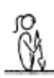 | - all positions must be performed with control and awareness  - maintain good body tension and alignment  - head neutral
 | 2. Pike | 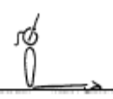 | - all positions must be performed with control and awareness  - maintain good body tension and alignment  - head neutral
 | 3. Front support | 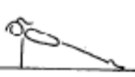 | - all positions must be performed with control and awareness  - maintain good body tension and alignment  - head neutral
 | 4. Rear support | 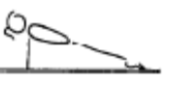 | - all positions must be performed with control and awareness  - maintain good body tension and alignment  - head neutral
Locomotion | Crawling along bench – with assistance
 | Walking on a masking tape line/rope
 | Log Roll Down slope with assistance
 | Egg Roll with assistance
Fwd Roll  (for front salto) | 1. Roll bwd & fwd to sit in tuck with assistance
 | 2. Roll bwd & fwd to sit in pike with assistance
 | 3. Roll bwd & fwd to sit in straddle with assistance
 | 4. Fwd roll down sloped mat with assistance | 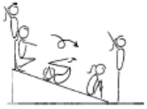 | - good speed in the rotation  - good rhythm in the rotation  - hands on the front of the shins, below the  - kneecaps  - head tucked in, with chin on chest  - stretch before and after the roll
Handstand (for walkover, handspring and flic flac) | 1. Rocking over a cylinder with assistance – on stomach to place hands on floor – walk 2 steps
 | 2. F1-2.1 Assisted front support on floor |  | - all positions must be performed with control and awareness  - maintain good body tension and alignment  - head neutral
Cartwheel / Roundoff | 1. F1-4.1 With hands on a raised surface, have the gymnast climb from one side to the other
 | 2. Assisted Rocking stars standing on a line – no movement fwd
Leaps/Jumps | 1. Straight jump drill from arm swing behind to stretched position – stay flat
FWO, BWO & Tic Toc | 1. Seal hold - assisted

GYM TOTS – BARS (1)
Hanging & Grip Strength | 1. Assisted Possum Hang Pull Ups (laterally hang under the single bar and chin up to left ear and then right ear)
 | 2. Assisted Straddle Hang | 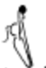 | - ensure good closure  - balls of the toes on the bar
 | 3. Assisted shimmy across
 | 4. Assisted swing in Long Hang on metal bar
Tuck Swings /Glides | 1. Assisted swing – drop bean bag in hoop
Front Support /Casts | 1. Assisted front support on floor with hands on floor bar | 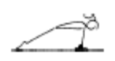 | - straight arms throughout the jump to front support  - chest rounded
Fwd Roll Dismount | 1. Assisted Tuck Hang
Pullover | 2. Assisted chin up hold – 3 secs
 | 3. Swing on rings in tuck position x 1 fwd and bwd (with box under so gymnast remains in tuck position)

GYM TOTS – BEAM (1)
Front support Mount | 1. Assisted jump to front support | 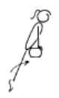 | - straight arms in front support  - legs straight during the first phase
Kneeling Scale | 1. Crawling along bench | 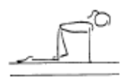 | - arms straight  - good rhythm  - head up, eyes down
 | 2. Bear walks along bench | 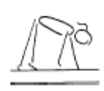 | - arms straight  - good rhythm  - head up, eyes down
Releve/Turns | On bench – assisted walk flat, 2, 3 – then rise to hold releve on toes – repeat along bench | 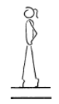 | - one foot slightly in front of the other, both legs slightly turned out  - legs squeezed together  - legs straight, knees locked  - heels pushed forward into a high arch shape  - ankles should be stable  - equal weight on both feet  - maintain good body tension and alignment
Locomotion | 1. Walk fwd on bench
 | 2. GF2.9 Side Steps along a bench – assisted
Jumps /Leaps | M1-7.1 Perform a releve on the bench with a beam bag on head – assisted |  | - one foot slightly in front of the other, both legs slightly turned out  - legs squeezed together  - legs straight, knees locked  - heels pushed forward into a high arch shape  - ankles should be stable  - equal weight on both feet  - maintain good body tension and alignment
Landing Drills | 1. Practise landing position | 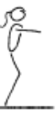 | - on landing the hips must be under  - on landing the shoulders, hips and ankles should all be in a vertical line
Straight Jump Dismount | 1. Holding parents hands– st jump off low beam to HOLD land for 3 secs

GYM TOTS – VAULT (1)
Landing | 1. © Mini Trampoline Straight Jump – focus on held landing
 | 2. GF1.6 Step-up, jump and land – SLP - hold
Bounce /Spring | 1. V1-1.1 Assisted bounces on the mini tramp – parent the gymnast by the hands in front
 | 2. GF3.7 Hopping – assisted
Running | 1. Running | 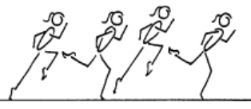 | - good body alignment  - fast action  - arms bent at 90', moving beside body  - legs moving within the body line  - body straight with slight forward lean  - maximum forward speed is essential  - head remains neutral and still
 | 2. Assisted running bwds
Hurdles | 1. 2 -3 step run – jump into hoop (take off from one foot)

